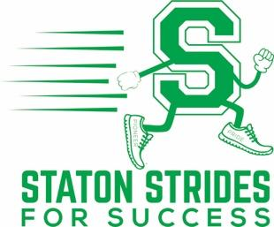
Teacher SS4S Wish List
Classroom teacher incentives from Administration & PTO:
- Top teacher in school (percentage based) gets wish list item(s) fulfilled
- Top teacher in each grade level (percentage based) will not have to attend the last “licensed” extra day of school – May 27 – and can check out a day early!!

Please list below items (with direct links) you would love to have in your classroom to aid in the education process of your students. CCSD provides all the necessities and Staton Administration assist with other items too but below are the type of items you go without due to budget constraints or aren’t necessary but would impact the education of students is a positive way.

Item(s) will be mailed directly to Staton Elementary at 1700 Sageberry Dr. Las Vegas, NV 89144 and are for the use of Staton students only.
 | Item description | Item cost | Exact item link
1 | ECR4Kids The Surf Portable Lap Desk, Flexible Seating for Classrooms, One-Piece Writing Table for Kids, Black (10-Pack) | $199.99 | https://www.amazon.com/ECR4Kids-Surf-Portable-Writing-10-Pack/dp/B07X1ZWZDX/ref=sr_1_8?dchild=1&keywords=Flexible%2BSeating%2BClassroom&qid=1611615433&sr=8-8&th=1
2 | Motivational Posters for Classroom, Inspirational Quotes Posters for Students Teachers Classroom Decorations 12 x 16 Inches (10 Pack) | $13.99 | https://amzn.to/3oNJRNv
3 | Learning Resources Create-a-Space Storage Center, Homeschool Storage, Fits 3oz Hand Sanitizer Bottles, Bright Colors, Classroom Craft Keeper, 10 Piece set | $15.74 | https://amzn.to/3oQ24dp
4 | Bright Plastic Organizer Bins - 12 Pack –Colorful Storage Trays, Modular Baskets Holders for Classroom, Drawers, Shelves, Desktop, Closet, Playroom, Office – 4 Color - BPA Free | $21.50 | https://amzn.to/39TZ7nG
5 | X-ACTO Electric Pencil Sharpener | XLR Heavy Duty Electric Pencil Sharpener, Quiet Motor, Pencil Saver Technology, Auto-Reset and Safe Start | $19.99 | https://amzn.to/3tGex7c
6 | Teachers Pay Teachers GiftCard | Any ☺ | https://www.teacherspayteachers.com/Gift-Card

